Event Response
When a catastrophe hits, insurer makes a legal promise to pay claims. But claims take weeks or months to arrive. Everyone who has a stake in business, like reinsurers, investors, management needs to know the loss position right now, not in three months.
Event response is how you produce that number before the claims arrive.
We do Event response because we need to know what a catastrophe costs our portfolio in hours, so we can reserve correctly, recover from reinsurers, protect our rating, and make better underwriting decisions before the next event hits.
It is the workflow that an insurer/reinsurer runs whenever a real-world catastrophe occurs (hurricane, earthquake, winter storm, wildfire, etc.) to figure out how much that event is going to cost the portfolio quickly, and with whatever information is available at the time.
The core problem it solves: when a live event happens, you don't yet have actual claims data so its the process of taking whatever signal is available about the event (a hazard footprint, a hurricane track, a vendor-published event set, or just an industry loss estimate) and running it against your own exposure data to produce a loss estimate for your specific book of business.
The event response should look at the possibility of the loss estimates arriving for various different types of events like hurricane, winter storm, flood, wildfires. Convective storms etc. there is significant uncertainty at the time of the event and the process defined should look at various data sources to come up with the loss estimates and claims count estimates to inform the claims adjusters, reinsurers and capital providers.
Since there is significant uncertainty at the time of the events, we need to look at:
- Various data sources to understand the physical parameters of the event
- Understand different building stock in that area and how damageability will be assessed
- Different financial terms to understand the net loss potential of the (re)insurer
The document outlines the different approaches used for various perils.
The workflow below is a generic flow of the data and process to provide high level overview. We will need to refine it further based on the peril and availability of information.
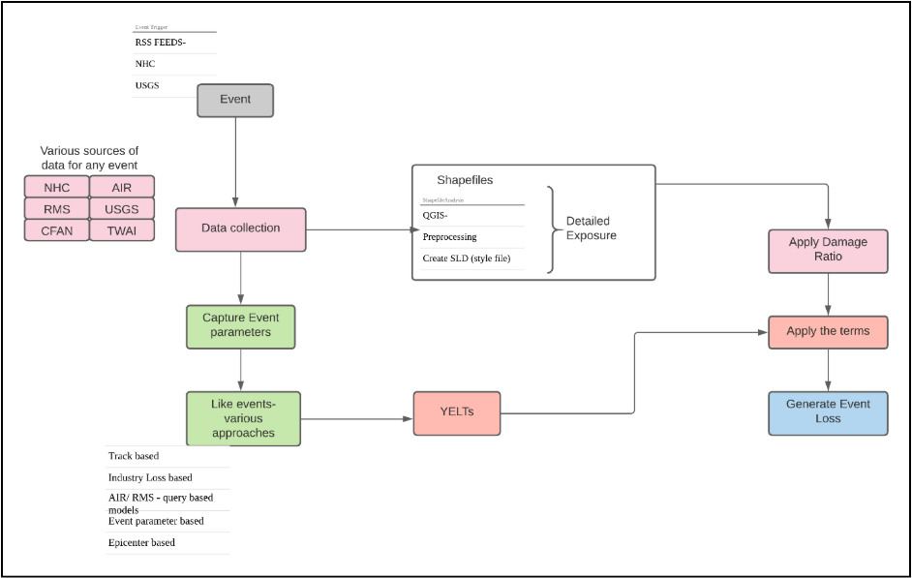
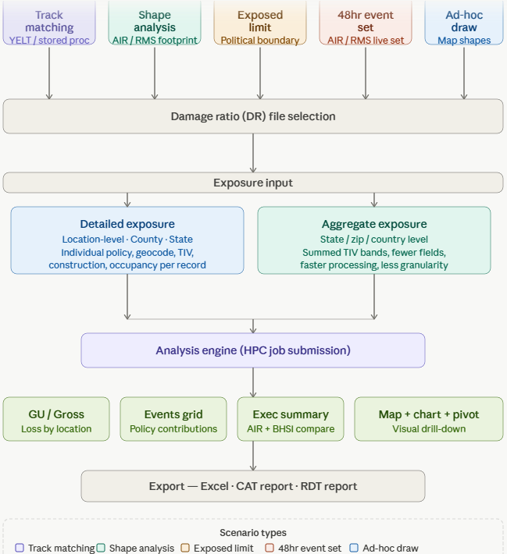
For hurricanes, the event notification happens well in advance, and typically initial advisory is provided by sites like NHC 5-10 days ahead of the landfall. While there is significant track and parameter uncertainty is present at the time of the initial event, nevertheless this information is still useful to better understand the loss potential of the event.
NHC provides the updated loss advisory every 6 hours, and hence entire process needs to be repeated after new information becomes available and until the event is dissipated completely. In addition to the NHC, various climate models provide data that can be further used to analyze the data and refine the loss estimates. The following process defines the hurricane event response lifecycle:
NHC declaration of event (T-5 to 10 days):
Start with the initial advisory of the event informing relevant stakeholders of the event and start collecting scientific data about the event.
Since there is a significant uncertainty about the track of the event and the actual event parameters as event passes over the sea, we will primarily rely on the track/parameter data to filter the existing stochastic catalog and find similar events in the catalog that match with the existing event. While it is very unlikely that we will be able to find exact match, this gives the initial guidance on the different event scenarios and range of losses that we may be able to expect from this event.
We will use the track and parameter match process at this time. The process may be extended to not only AIR stochastic catalog but other modelers as their data becomes available.
6-hour intervals:
We will use the track and parameter match process at this time.
Before landfall (T-2 days):
The track and parameter uncertainty goes down significantly 48 hours before landfall and now additional information may become available. The additional information includes shape files of the event, track information and parameters. We will then use this information to come up with the event shape file (if it is not readily available) and will start shape file analysis to come up with more refined information. We will also use vendors provided like events to understand the loss potential.
We will need to provide detailed information to the stakeholders about the loss ranges as well as probability and claims count.
At landfall (T):

Significant information becomes available from various sources at the landfall. In addition to the scientific information above, we may start to get additional landfall information which can further be used to refine the list of like events and shape file analysis.
After landfall (T+2 days):
In addition to the information above, additional information like detailed scientific information about the events, satellite imagery, initial claims report etc. will start to come in at this time. We will use this information to refine the loss estimation process further. We will also start to see the industry loss estimates from various sources. We can also assess the impact of secondary perils like storm surge at this point and significant information like surge inundation footprints will be available at this point. We can overlay these shape files on the detailed exposure available to come up with refined loss estimates which can help in reserving.

For other perils like earthquakes, winter storms, wildfire, severe storms, most of the information is available after the event has happened so detailed analysis and loss estimates can be provided only after the event. The document will initially focus on hurricanes, but similar approaches can be extended to other perils as well as information related to those perils become available.

Method | YELT Requirement | Detailed Exposure | Aggregate Exposure
Industry Loss | ✓ | X | X
Track matching | ✓ | X | X
Parameter @ Landfall | ✓ | X | X
Exposed Limit | X | ✓ | ✓
Shapefile | X | ✓ | ✓
Ad-hoc Draw | X | X | ✓

Aon uses Latest NHC and hurricane forecast models to loss estimates and associated uncertainty in event response. Using detailed exposure data, doing storm monitoring with actual forecast data, generating footprint by IF’s wind model and damage function and generate losses.
Link: Automated Event Response | Aon and pdf
WTW is using Global Peril Diagnostic doing predictive modeling and real time alerts on exposure data for 12 perils. GPD help clients to prepare and respond to natural catastrophes and climate peril with a dynamic, real-time evaluation of current and potential business investments.
Link: Global Peril Diagnostic - WTW
RMS- Event Response Services – Moody's
AECOM, Marsh and Gallagher has their own disaster response system but information is not too much available on open source.

Why exactly can’t models get claims count?
The relationship between wind speed and Mean Damage Ratio (MDR) explains how hurricane-induced damage is estimated within a model.
For example, when a hurricane reaches a wind speed of 40 mph, a building may begin to experience damage, and as the windspeeds hit about 60MPH, the model may estimate an MDR of 20%. As wind speed increases, the expected damage generally increases, resulting in an upward-sloping vulnerability curve.
However, actual damage can vary significantly from the average MDR predicted by the model. For instance, if a policyholder leaves windows open before the event or if the roof has pre-existing damage, the resulting Damage Ratio (DR) could be significantly higher than the modeled MDR, potentially reaching 90–100%. Whereas in opposite, properties with mitigation features such as engineered shutters, impact-resistant windows, or reinforced concrete roofs may experience much lower damage, perhaps only 5–10%.
Therefore, the MDR represents only the average expected damage for a given wind speed. There is always uncertainty around this estimate, it can spike up or down the uncertainty giving the different weightage, and the actual damage can vary considerably above or below the MDR. This uncertainty is represented by the spread of possible damage outcomes around the mean vulnerability curve.
Eg:
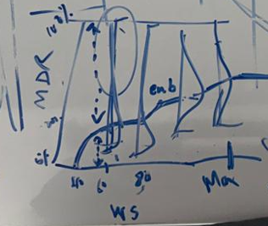
0-40 mph: Building will start to experience any damage at certain speed only
40–60 mph: Small exterior damage begins to occur, resulting in a gradual increase in damage
60–80 mph: The envelope will breach and house will be open. Once the envelope is breached, internal pressure and water intrusion can cause severe damage to both the structure and contents, leading to a much sudden increase in damage.
Higher wind speeds: Damage accelerates rapidly, and total losses become increasingly likely.
At every wind speed, a range of potential damage outcomes exists around the average MDR i.e. +-MDR. While models use the MDR to estimate expected losses, actual losses for individual properties may differ substantially due to property-specific characteristics and event conditions.
When the damage ratio is changed into insured loss, policy terms such as deductibles and limits are applied. Losses below the deductible are retained by the policyholder, while losses exceeding the limit are also paid by policyholder. As a result, from the insurer's perspective, the model primarily captures losses that fall between the deductible and policy limit. The modeled loss therefore represents the average expected insured loss after accounting for these policy conditions.
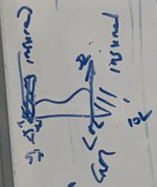
Simply, CAT models estimate loss amounts (damage and financial loss), not whether a policyholder will file a claim. Model calculates an average damage ratio (MDR) and then estimates the insured loss after applying deductibles and limits. A claim is a business outcome, not purely a physical damage outcome. This is the reason why we can’t have claims count.
Due to the uncertainty around the MDR, the model will always have some probability of loss above the deductible even for a small mean GU loss, so $10 mean GU loss may generate $2 of GR loss while $10 loss will fall under the deductible and will not generate any claims. This essentially makes models overestimate the overall count of the locations that will get damaged by overestimating the claims count significantly.
The insured will file a claim only when losses are near or above the deductible. So, we will need to safely reduce the claims count when the Ground Up lose <90% of deductible and then estimate the claims count.
Process Constraints:
  - Exposure data constraints
  - Wind Data constraints with observed wind speed
  - Model- calculations being done on MDR only
  - Claim count and loss estimation
  - Unknown output- Efficiency
  - Validating the output constraints
  - Getting output in 1-2 hours when NHC will push data in every 6 hours

Ensemble Track method:
Workflow:

Track ensemble Method:
- Downloading NHC forecasted track from advisory – will give cone of uncertainty, line track and points- check if wind speed info available along the track
NHC site: NHC Data in GIS Formats with shapefile of point, line and polygon (cone of uncertainty)
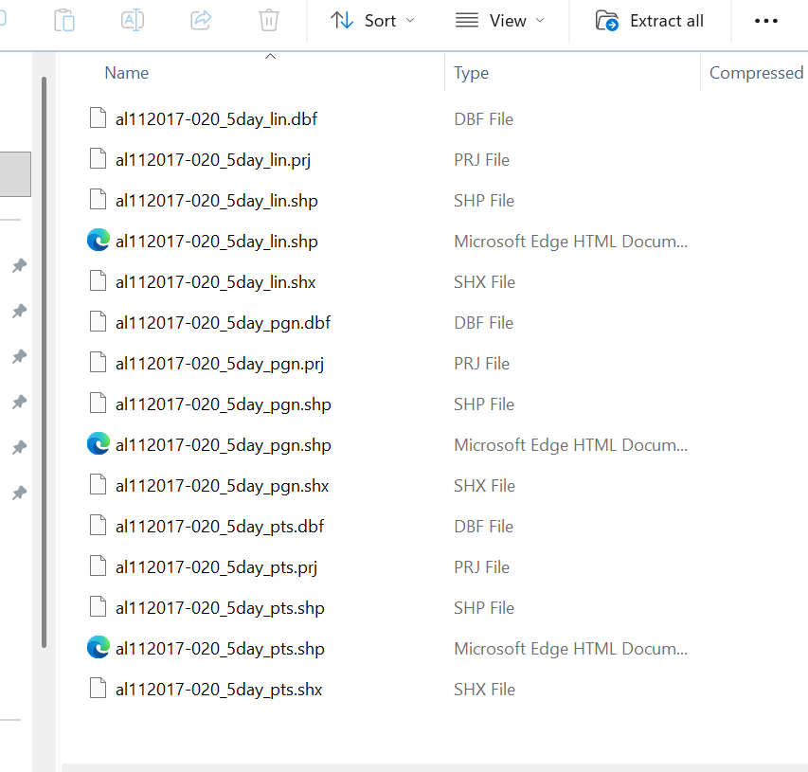
Every advisory should be named according to date and timestamp information like this
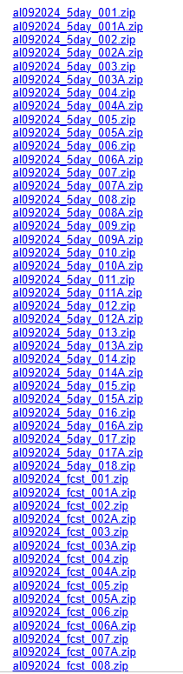
Nomenclature logic: Identifiers are "al" for Atlantic storms and "ep" for East Pacific storms. Storms are numbered sequentially beginning with the first storm each season.
- In the cone of uncertainty, create 1-5000 probabilistic tracks
- If the forecasted cone, hits US boundary then its fine otherwise if it doesn’t hit US boundary, create Landfall Projection Engine which will give us landfall’s- Lat, long, wind speed etc.
- Extend tracks
- Intensity evolution
- Instead of geometrical tracks, use other parameters – steering flow
- Historical analogue correction- to look historical tracks and correct the track- ibtracs-
- Landfall detection- intersection of coastline and track
- For each track we will create a wind field model
- It will give wind speed at every grid point and creating this into raster file
- Then will be converted to vector shapefile with wind speed bands and stores metadata like category, wind speed under wind speed band etc.
- SLD will be applied which will do color coding and legends for visualization
- Then it will be saved as multiple trackID shapefile
- These trackID will be matched against AIR 50K kml file and it will give the eventids
- To create 3 checkpoints at equidistant from one track
- Create 3 circles or buffer zones around those points of certain radii
- Will find all the common eventID passing through those zones, filtering from AIR 50k KML file
- Once we have eventID, then we can get the Event description table and see the Parameters like Landfall’s county, State, Max Wind speed, central pressure, category and compare those parameters
- This will give the refined EventIDs
- I have to see- what category is matching with the actual category with eventID
- Filter the YELT based on the compared eventID
- Look to YELT of portfolio- input- filter the gross losses based on event
- On 1 trackID we will get multiple EventIDs, on the basis of which we can create a loss matrix like this:
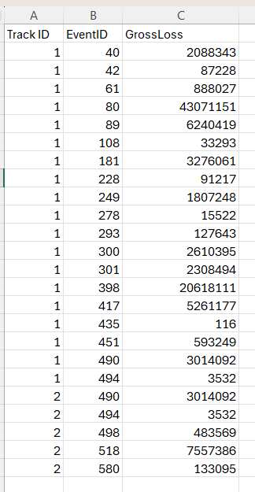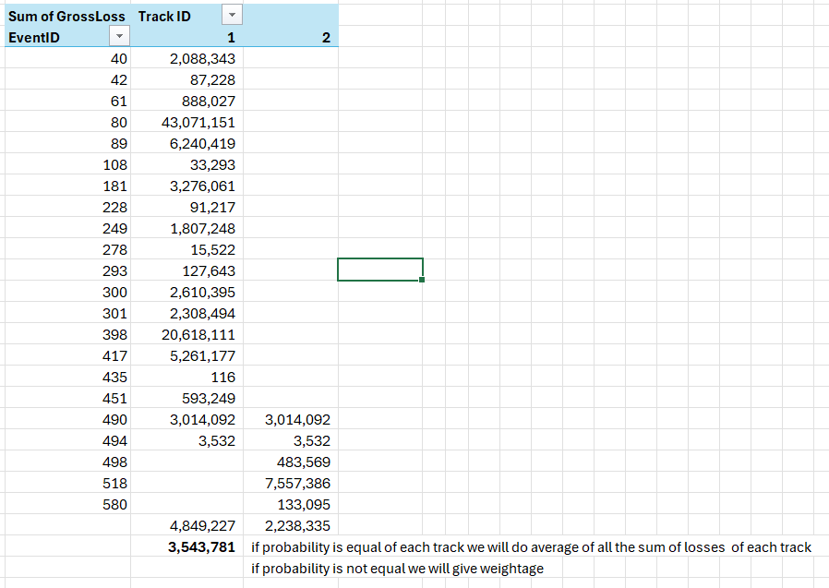
- Our shapefile will be having metadata like TrackID, wind band, min wind, max wind, Landfall State, county
- We will do now Shape analysis, Ring analysis, Exposed Limit analysis, Ad-hoc /Draw analysis
Method | YELT Requirement | Detailed Exposure | Aggregate Exposure
Industry Loss | ✓ | X | X
Track matching | ✓ | X | X
Parameter @ Landfall | ✓ | X | X
Exposed Limit | X | ✓ | ✓
Shapefile | X | ✓ | ✓
Ad-hoc Draw | X | X | ✓

- Will use SLD applied shapefile (projection 4326 (WGS 84) and perform this analysis based on the exposure we have- detailed or aggregated exposure, then apply the Damage Ratio- deterministically or by csv.
 | Shape Analysis | Concentration/Ring Analysis | Ad-hoc/ Draw Analysis | Exposed Limit Analysis
Input | Shape files (1-5000 shapefiles) | Circles of different radius | To draw in shaped like- circle, square, rectangle, polygon, Line band etc. | Political Boundaries like pin code, county, State, Area, Country etc.
Damage Ratio | File | File | File | File
Process | Based on the shapefile selected will apply the DR | DR will be applied separately @ location level and calculate losses in ring | Will select the shape over exposure then on the basis severity will apply DR, Ultimately Loss | Political boundary will be selected, based on which DR apply and give Loss
Output | Loss | Loss | Loss | Loss

- Shape analysis-
- Analysis name based on the event name, date and timestamp
- Will be saved in folders like- NHC > Ian > Original Date > timestamp > Point, Line and Polygon shapefile
Analysis name > selecting Hazard shapefile out of 5000 (which eventname, date and timestamp version track we will use and have information like TrackID, Category, windspeed, Wind band, Lat Long) > selecting exposure (have info like location ID, Lat Long, TIV) > converting exposure to point layer shapefile > Damage ratio file > output
Before applying DR- When hazard and exposure shapefile will intersect it will give me TrackID with Category along with wind speed on LocationID (exposure)
Now DR will be applied based on Wind Speed Bands
For Damage Ratio- With respect to wind speed bands, we will be using Damage ratio file. Here attribute value is wind speed eg.,
Min Attribute Value | Max Attribute Value | Damage Ratio (%)
0 | 4 | 50
40 | 80 | 60
80 | 120 | 70
When we are going to use detailed exposure, we will have detailed DR file like this-
Min Attribute Value | Max Attribute Value | Construction Type | Occupancy Type | DR (%)
0 | 40 | Light Metal | Education | 0
40 | 50 | Light Metal | Education | 0.0057
50 | 60 | Light Metal | Education | 0.025

Like this we will be having combinations. If one misses or other presents or by weightage the DR will be assigned.
Process:
- After intersection ill get the trackID with Wind speed on each location
- Then Damage ratio will be applied independently based on the wind speed bands from the provided file and hence calculating the loss at each location since we have TIV

1st Method- Track matching: YELT / stored procedure-
- Can be done by integrating both track matching and event parameter approach
- Need Exposure -Bound Portfolio/Insurance/ Reinsurance portfolio
- Track shapefile (including Polygon, Points and Line-track from NHC)
- Check Parameters like- SS category, Lat-Long for matching like events and
- EventID if we Source the YELT file- For parameter-based analysis
- Check stored proc existence- document inputs (event ID, peril, year range)
- Apply DR & run – show in activity monitor
- Output- matched location set, EventIDs, loss values
A hurricane or typhoon has a defined path, i.e. has latitude, longitude, and wind speed at every point along its track. AIR and RMS have already modelled thousands of historical and synthetic tracks in their stochastic catalogues. Track matching exists because the best similarity for a live hurricane is not a guess, similar track from the catalogue that has already had losses. We use it when we have track information, but exposure is not defined.
Input Parameters and possible sources:
Input | Source
Live event track data | NHC, JTWC, IBTrACS
Wind speed / intensity | NHC advisories published every 6 hours during active storm, HURDAT2 historical database for past events
AIR/RMS stochastic YELT Table | AIR/RMS Touchstone
Portfolio exposure file | Available internally

Purpose- To find simulated events whose tracks are intersecting with upcoming event based on NHC data
How this method will be used?
Input:
- To get the track shapefile, go to NHC site link - NHC Data in GIS Formats and download the shapefile of any forcasted event
- The NHC track Shapefile contains three types of data- Point, Line and Polygon

- Along with this download shapfiles for US coastline and US State (link)
- With this AIR event catalog of hurricane track is required. For eg. 50K KMZ file
Process:
- Run the “functions.py” file before using this python script
- Using Python script, we can convert this shapefile directly to tracks that could be shown on map
track timestamp- front end and backend
- Read the NHC forecast Polygon and Line shapefile, AIR simulated event tracks, and US map data shapefile
- Generate checkpoints or a specified number of equidistance points along the forecasted track. In code, its – “num_points”
- We have used 3 that means one may be starting of forecasted track, one in between and one at the end
- Then around these 3 checkpoints, we will create circle area (buffer)
- These circles contains only those only practical track paths that can be captured in NHC forecast cone
- Then we will capture those AIR simulated Events that are coming in the circle ranges (here its 3)
- Then we will filter those particular EventsIDs from the AIR catalog. We will say these particular events have similar events to the forecasted hurricane
Output:
Then we will save this output of matching EventIDs to the csv file as a list. For eg- EventID- 270000402, 270000498
Python script:
- from functions import find_events_passing_circles
- ## fixed input files
event_track_file = "Y:/AIR_EventsDB/M27_10K_WSST_Event_Tracks/M27_10K_Event_Tracks.shp"
us_map_shape_file = "Y:\\Code\\Data Quality\\Data Files\\US State Shapes.csv"
- ## Input File Path
polygon_shape_file = "Y:/Live CAT Events/2022/Ian 2022/Dry Run June 2023/9-27-22/QGIS/al092022_5day_017A/al092022-017A_5day_pgn.shp"
line_shape_file = "Y:/Live CAT Events/2022/Ian 2022/Dry Run June 2023/9-27-22/QGIS/al092022_5day_017A/al092022-017A_5day_lin.shp"
num_points = 3
- passing_events = find_events_passing_circles(us_map_shape_file=us_map_shape_file,event_track_file=event_track_file,polygon_shape_file=polygon_shape_file, line_shape_file=line_shape_file, num_points=num_points)
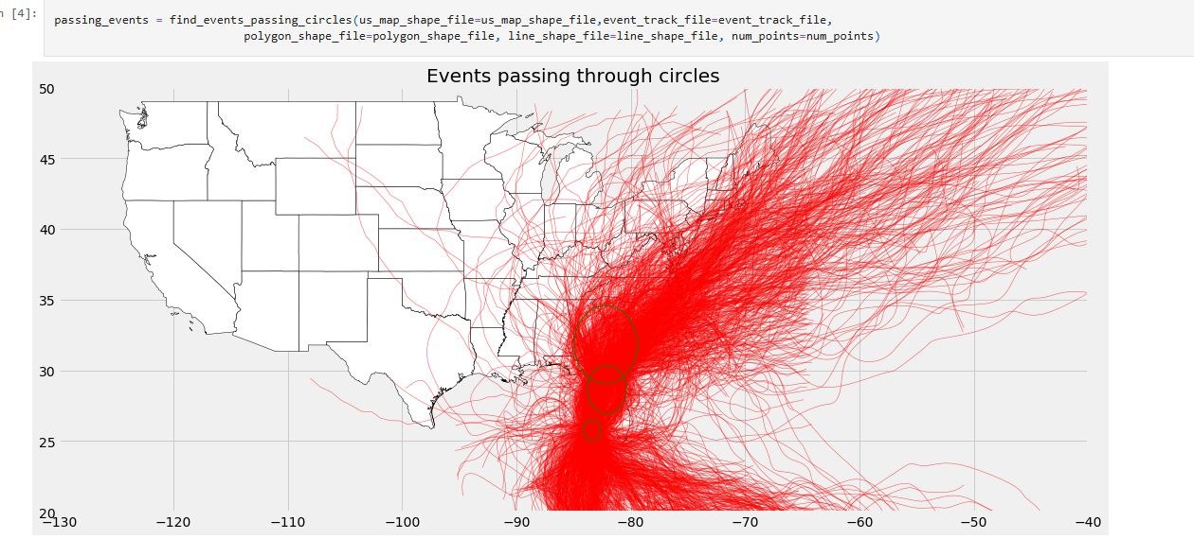
- passing_events

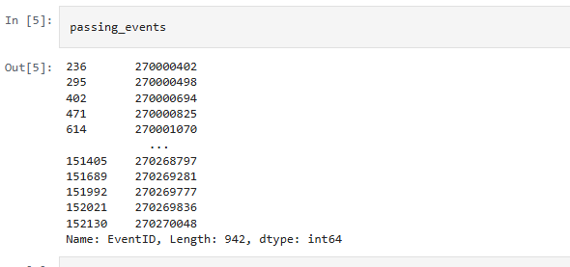
- ## File in saved in "Y:\Code\Crown Event Response\Track Analysis\AIR_LikeEvents_Track_Analysis_result.csv"
passing_events.to_csv('AIR_LikeEvents_Track_Analysis_result.csv')

For Parameter based approach-
Purpose: To identify historical or simulated AIR events that have characteristics similar to an current/forecasted event. Event Parameter Analysis is effective when a hurricane is approaching landfall and reliable forecast data is available.
Usual scanerio include: 6–12 hours before landfall, Landfall prediction, Rapid event response, Loss estimation, Scenario analysis
The approach can also be combined with Track Analysis to improve confidence/accuracy in the selected like events.
- Instead of comparing tracks, this approach also compares event attributes such as- Lat, Long, Max Wind Speed, Central Pressure, S-S Category, Landfall Status, Distance to Coast etc.
- It will give us the Like events as the output
- When a live event occurs, the available event data is loaded into an input table.
- A SQL pipeline then applies predefined filters and ranges to AIR's event catalog to identify events with similar characteristics.

Inputs for event track analysis
- Longitude, Latitude
- Radius
- Guid (Unique text identifier)
- IsTrackAnalysis = 1
Output of event track analysis
- Output Shape Table Name - [ARAPL_LiveEventData].[dbo].[AIR_Shapes_{guid}] (guid is input)
- Output Like Events Result Table Name – [ARAPL_LiveEventData].[dbo].[AIR_LikeEvents_Tracks_{guid}] (guid is input)
Inputs for event parameter based analysis
- Input Table – [ARAPl_LiveEventData].[dbo].[AIR_inputParameterTable]
Output of event parameter based analysis
- Output Like event result table name – [ARAPL_LiveEventData].[dbo].[AIR_Filtered_EventID_{guid}] (guid is input)
Inputs for Industry Loss based analysis
- Input Table - [ARAPl_LiveEventData].[dbo].[AIR_inputParameterTable]
Output of Industry Loss based analysis
- First two resultant tables,
- Table 1 with event info and industry loss
- Table 2 with event info, industry loss with area and subarea

The SQL pipeline have:
SQL Query- \\pimcloudshare\ils-share\Live CAT Events\LiveCATonCrown\AIR Event Response
Pipeline query- \\pimcloudshare\ils-share\Live CAT Events\LiveCATonCrown\AIR Event Response\AIR_pipeline_EventResponse.sql
Input parameter query- \\pimcloudshare\ils-share\Live CAT Events\LiveCATonCrown\AIR Event Response\AIR_InputParameterTable.sql
For running parameter based analysis-
- For input table – open Input Table Query- AIR_InputParameterTable.sql
- Insert Event Parameter value as described in SQL comments
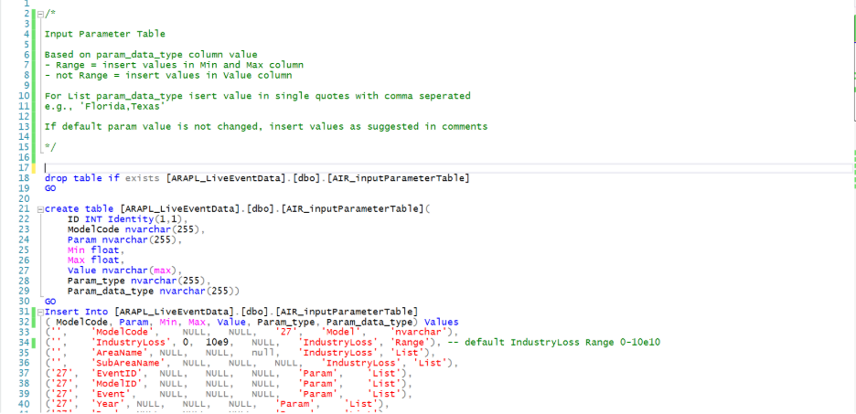
- Make sure to fill default value from comments to specified parameter
- Execute query to create and populate the input table.
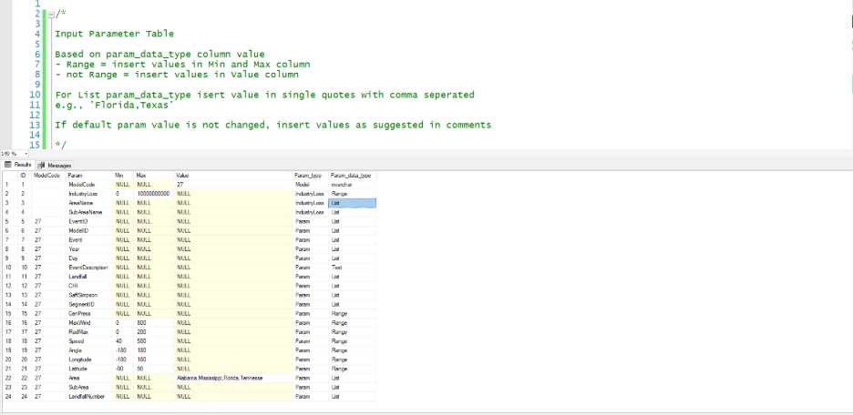
- For pipeline query, Make sure to create input table before executing query and insert parameter in input- AIR_pipeline_EventResponse.sql
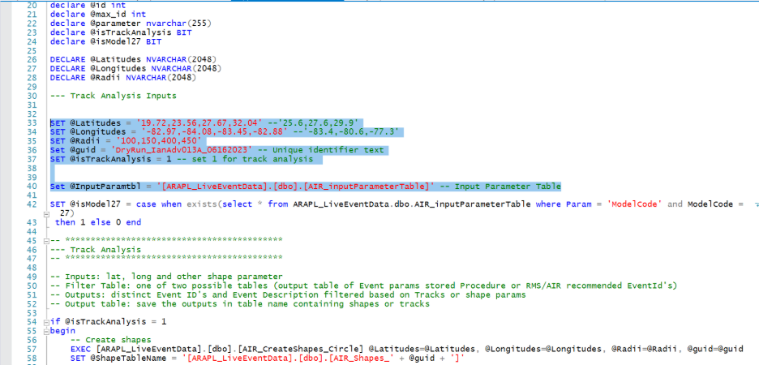
- Execute query which gives you below output
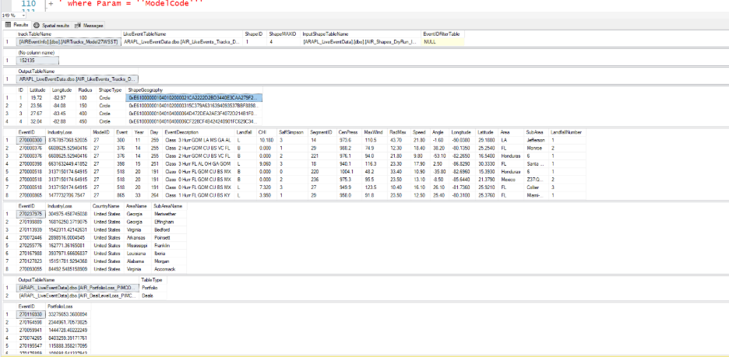
- The pipeline compares the input event against AIR's historical and stochastic event catalog by filtering AIR Event Catalog.
- Events are selected if they satisfy the specified conditions. For eg.- Within ±1 degree lat/long, same ss category, wind speed, central pressure, landfall characteristics
- Matching events in table- ARAPL_LiveEventData].[dbo].[AIR_Filtered_EventID_{guid}]
where guid is global unique identifier provided for the analysis and it will have- Event ID, Matching event characteristics
Exacution- AIR_InputParameterTable.sql > AIR_pipeline_EventResponse.sql > [ARAPL_LiveEventData].[dbo].[AIR_Filtered_EventID_{guid}]
For eg- Hurricane Harvey will produce the following results:
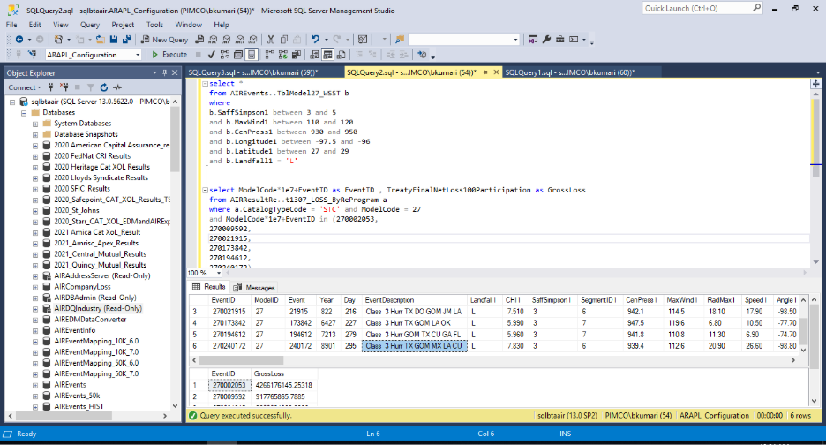
- This approach is suitable for situational or conditional analysis, where a set of conditions are true for a particular point of data.
- For this we selected using pre-landfall observations, and a set of predefined conditions. Included parameters criteria like: Lat and Long- one and a half degree only, Max Wind Speed, SS category, landfall status
- The query searched AIR's event catalog for events satisfying all specified conditions.
- The results are majorly dependent on selected parameter values. Small changes can significantly change the set of matching events. For eg.- Increasing the lat/long from ±1° to ±2°, SS category, changing central pressure range or changing the wind speed threshold
- This may result in a completely different set of matching events.
- Because of this reason, multiple repetitions of the query are required to evaluate different scenarios and understand how changes in hurricane, impact the resulting like events.

Two separate analyses were performed:
  - Track based analysis which got 4-like events; EventIDs found
  - Event Parameter analysis which got 6- like events; EventIDs found
Using both methods together will provide potential like events and loss outcomes and we will pick the matching EventIDs between Track matching and Parameter based approach
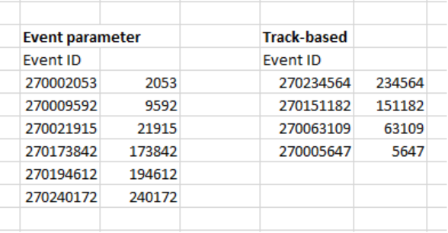

Steps to create “like event” analysis report in Excel
- One Excel file and save it “Analytics” folder and create following tabs
- Readme - information about occurring events, data source links, general summary of Like Event analysis process and charts
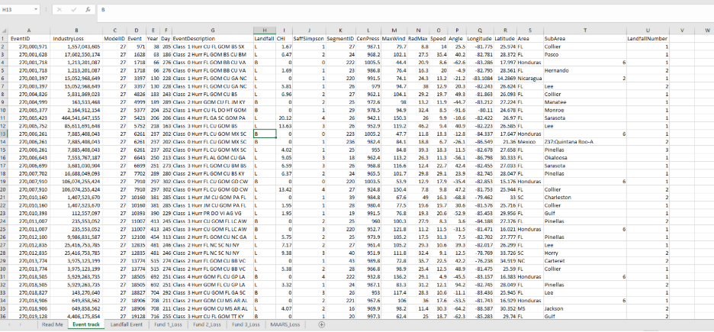
- Landfall Event - information about Like Events Landfall information and Industry Loss with Area and Sub Area
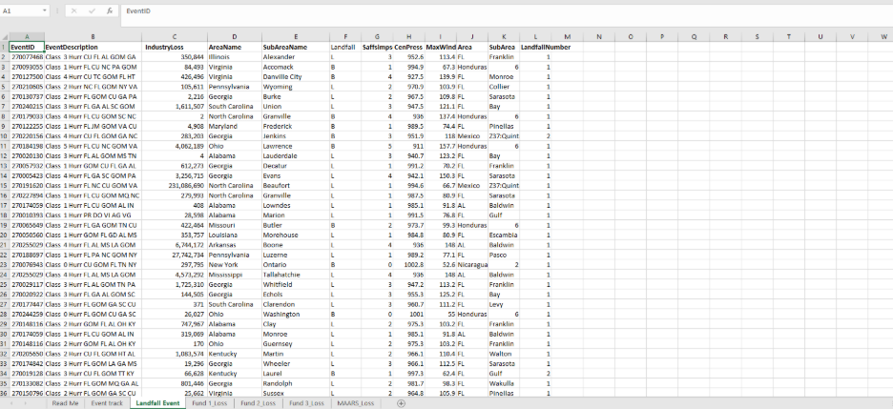
- Fund 1 Loss – information about Event Track with Industry Loss, Portfolio Loss and Deal Loss as form in Columns for Fund 1
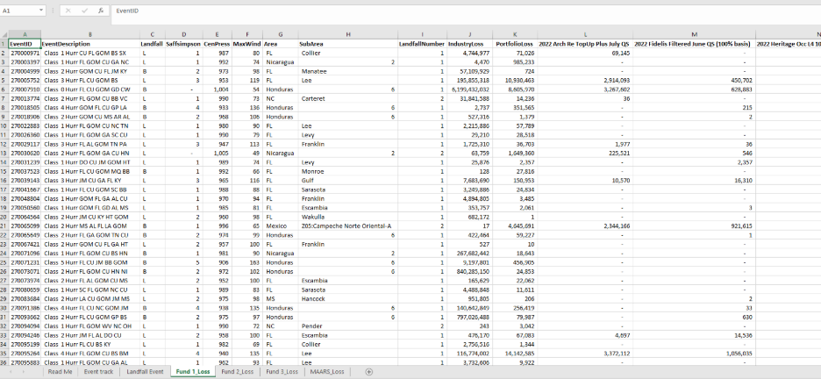
- Fund 2 Loss – information about Event Track with Industry Loss, Portfolio Loss and Deal Loss as form in Columns for Fund 1
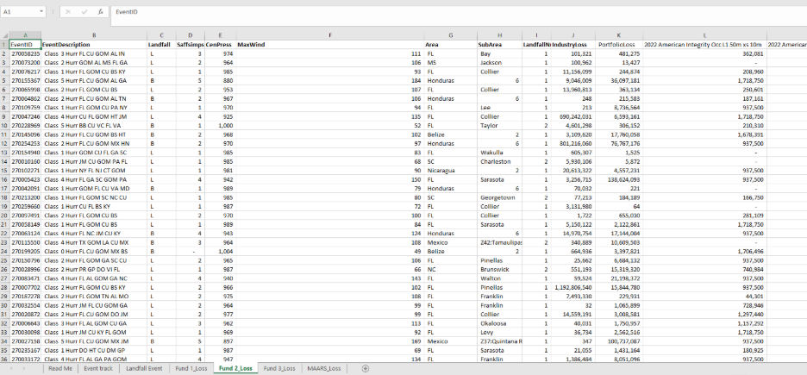
- MAARS Loss –information about Event Track with Industry Loss, Portfolio Loss and Deal Loss as form in Columns for Fund 1
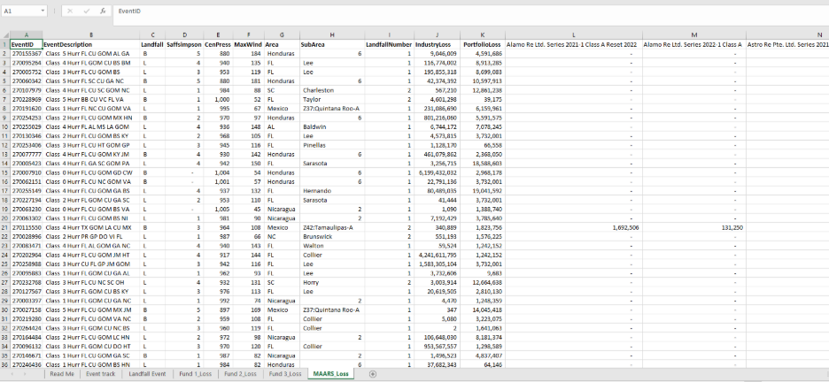

Industry Loss Approach:
Purpose: To identify historical or simulated events that produced industry losses like an event.
Useful for perils that do not have a well-defined track or event parameters, such as Winter Storm
Inputs e.g.:
Parameters- Peril- Winter storm, Area- Texas, Industry Loss Range - $2B - $5B
Data Sources: AIR Event Catalog, AIR Event Information Table, Industry Loss Data, Analyze Re Portfolio Data (optional)
Process:
- Capture the available information for the live events like Peril, Affected Area, Estimated Industry Loss
- Use query to get AIR Event Catalog and Filter AIR stochastic events using matching peril, matching area, Industry loss criteria. Eg.:
WHERE Peril = 'Winter Storm'
AND Area = 'Texas'
AND IndustryLoss > 2000000000
- Get Event Details by joining filtered events with AIR Event Description Information tables to get- Event ID, Event Description, Model Code, Industry Loss
- Save results of matching events in output table/ export to xlsx/csv that will contain: Event ID, Event Description, Industry Loss, Area, Peril
Output: eg.
Matching Events Found: 72
Model Code: 28 (US Winter Storm)
Analysis showed:
- ~50 events had Texas losses between $2B and $3B.
- A small number of events contributed significantly to total US Winter Storm losses.

How to publish shape file:
Input Exposure
1. Detailed exposure-
Coarseness- Location level
Fields- TIV, geocode, build class, occupancy, year built, stories
Geocoding- Address match quality
DR granularity- Per location / per construction
Processing time- Slower — more records
Higher Precision in output

2. Aggregate exposure
Coarseness- State / zip / county level
Fields- Summed TIV bands
Geocoding- Not required
DR coarseness- Zone / region level only
Processing time- Faster
Band estimates therefore low precision in output

2nd Method- Shape analysis: AIR / RMS event footprint
- Hazard shapefile from AIR/RMS
- Integration of GIS
- Select Peril
- DR file selection
- Submit Peril Analysis- show in activity monitor
- Output- map shows footprint overlaid on locations with losses
Why?
Once AIR or RMS publishes an official event footprint a polygon showing the geographic extent of the hazard (wind field, shake map, flood depth) we have a precise boundary. Shape analysis exists because this becomes purely spatial once we get this. We can answer- which of my locations fall inside that boundary, and what does the damage ratio say they will lose? We use it when a vendor footprint exists and we want location-level precision.
Input Parameters and Possible Sources:
Input | Source
Hazard shapefile, hurricane wind field | NHC, AIR/RMS event response rapid footprint
Hazard shapefile — flood extent | FEMA National Flood Hazard Layer (msc.fema.gov); Copernicus Emergency Management Service (EMS) for international events; AIR flood footprint
Hazard shapefile — tornado / convective storm | NOAA Storm Prediction Center (spc.noaa.gov) — storm reports and convective outlooks; AIR convective storm footprint
Damage ratio file | Available internally
Portfolio exposure file | Available internally
Publish Shapefile | publishes shapefile into Product using backend python query involving QGIS method

Output- Published shapefile showing footprint overlaid on locations with losses
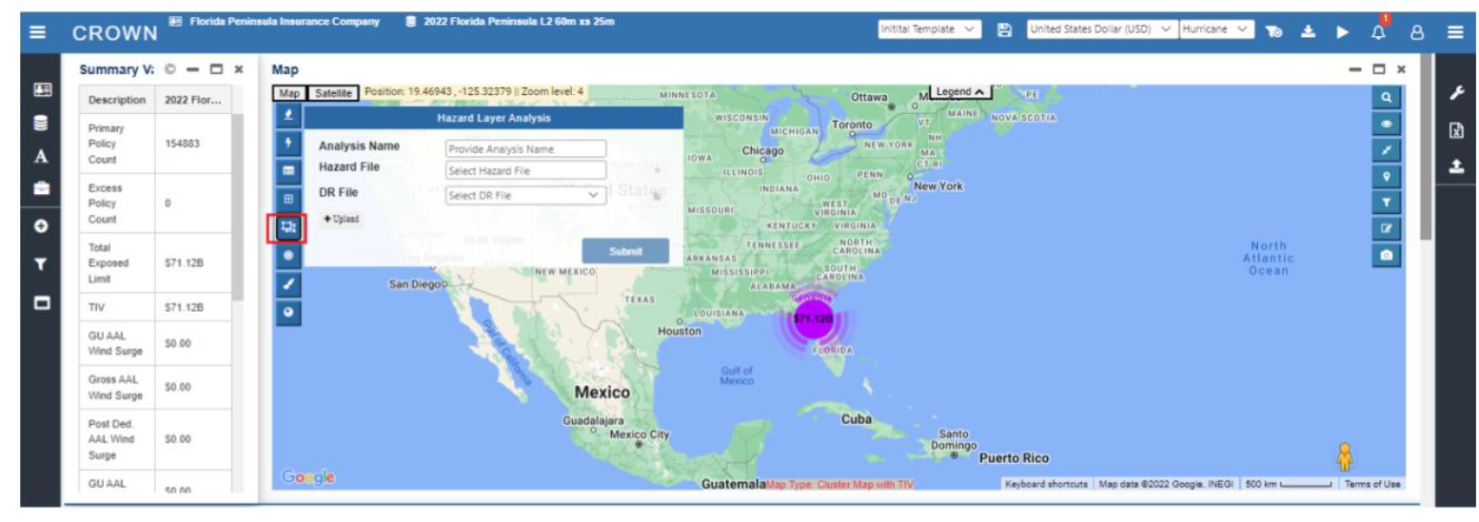

As per Earlier document:
Inputs for event track analysis
- Longitude, Latitude
- Radius
- Guid (Unique text identifier)
- IsTrackAnalysis = 1
Output of event track analysis
- Output Shape Table Name - [ARAPL_LiveEventData].[dbo].[AIR_Shapes_{guid}] (guid is input)
- Output Like Events Result Table Name – [ARAPL_LiveEventData].[dbo].[AIR_LikeEvents_Tracks_{guid}] (guid is input)
Inputs for event parameter based analysis
- Input Table – [ARAPl_LiveEventData].[dbo].[AIR_inputParameterTable]
Output of event parameter based analysis
- Output Like event result table name – [ARAPL_LiveEventData].[dbo].[AIR_Filtered_EventID_{guid}] (guid is input)
Inputs for Industry Loss based analysis
- Input Table - [ARAPl_LiveEventData].[dbo].[AIR_inputParameterTable]
Output of Industry Loss based analysis
- First two resultant tables,
- Table 1 with event info and industry loss
- Table 2 with event info, industry loss with area and subarea

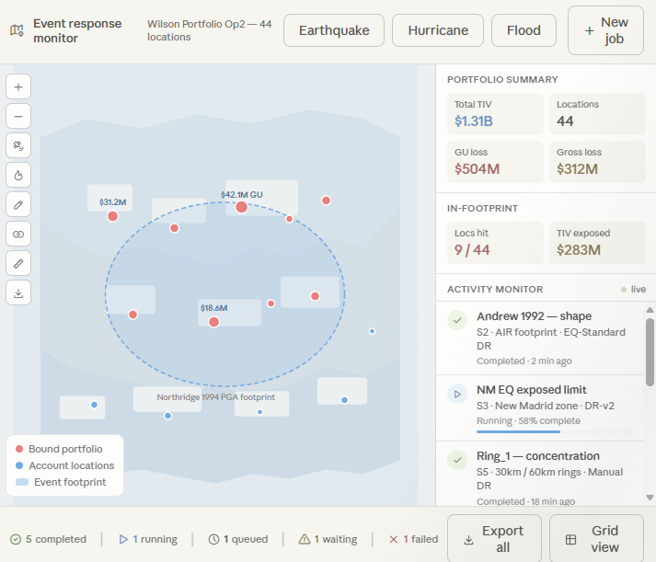

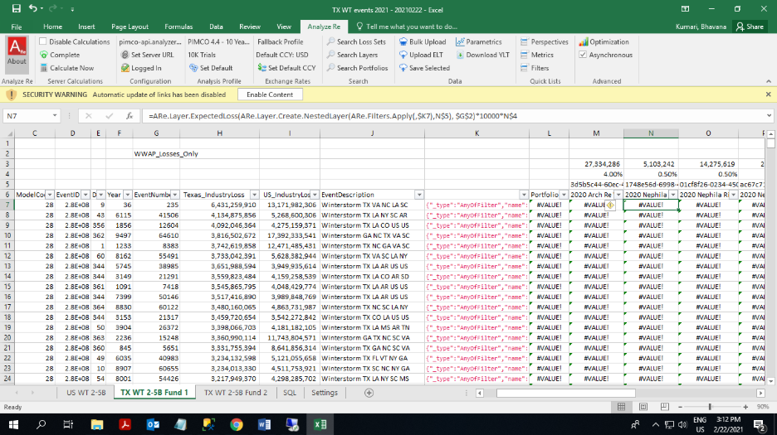

Event Response Method Matrix:
S. No. | Method | Best Use Case | Required Inputs | Optional Inputs | Exposure Type Supported | Processing | Outputs
1 | Track Matching | Event just occurred | Event Name, Event Date | Event ID | All | Match against Event DB/YELT | Existing Event Found/Not Found
2 | AIR/RMS Event Set | Vendor event available within 24-48 hrs | AIR/RMS Event Set | Exposure Filters | Detailed | Run vendor footprint | Gross Loss, Net Loss, AAL Impact
3 | Shape Analysis | Footprint available | Shapefile + DR | Custom DR | Detailed | Polygon Intersection | Loss by Location
4 | Exposed Limit Analysis | Aggregated exposure | ZIP/County/State Exposure | DR File | Aggregate | Political Mapping | Loss by Region
5 | Draw Shape Analysis | Emergency manual analysis | User Drawn Polygon | DR | Detailed | Shape Overlay | Exposure + Loss
6 | Industry Loss Approach | No exposure details available | Industry Loss Estimate | Market Share | No Exposure | Scaling Method | Portfolio Loss Estimate
7 | Hybrid Method | Multiple data sources | Shape + Industry Loss | AIR/RMS | Any | Weighted Approach | Range of Loss Estimates

Exposure Type and suitable Method
Exposure Available | Shape Analysis
Location Level | ✅
ZIP Level | ⚠️
County Level | ⚠️
State Level | ❌
Portfolio TIV Only | ❌
No Exposure | ❌

Approach:
  - Need to go through the document and try to write What? Why? and How?
  - Review the process of the methods available with us and try to improve it.
  - Damage Ratio file and application logic
  - Check the SQL scripts and databases along with python codes whether they are working?
  - Create a user documentation after checking the working on the product

References:
Open sources:
NHC — National Hurricane Center
Track data, wind radii shapefiles, advisories- https://www.nhc.noaa.gov
GIS shapefiles specifically- https://www.nhc.noaa.gov/gis
USGS — ShakeMap (earthquake footprints)
Historic and real-time shake intensity polygons downloadable directly- https://earthquake.usgs.gov/data/shakemap
USGS — Hazards general
Earthquake, landslide, volcano, flood hazard data- https://www.usgs.gov/natural-hazards
Latest Earthquakes
IBTrACS — International Best Track Archive for Climate Stewardship
Global historical hurricane / typhoon track database- https://www.ncei.noaa.gov/products/international-best-track-archive
HURDAT2 — Atlantic hurricane database
CSV track data for all Atlantic storms (From 1851)- https://www.nhc.noaa.gov/data/#hurdat
NOAA Storm Prediction Center — convective storm reports
Tornado, hail, wind reports and outlooks- https://www.spc.noaa.gov
Storm data- https://www.spc.noaa.gov/wcm/#data
NOAA National Weather Service
Winter storm, freeze, and severe weather event summaries and weather status- https://www.weather.gov
Event archive- Climate Monitoring | National Centers for Environmental Information (NCEI)
https://www.ncei.noaa.gov/access/monitoring/weekly-palmers
FEMA — Disaster declarations
Official US federal disaster declaration list by state and event type- Disaster Information | FEMA.gov
FEMA — National Flood Hazard Layer
Flood zone shapefiles by county and state- Flood Data Viewers and Geospatial Data | FEMA.gov
US Census Bureau — TIGER/Line shapefiles
Political boundaries: state, county, zip code, tract level- https://www.census.gov/geographies/mapping-files/time-series/geo/tiger-line-file.html
GADM — Global Administrative Boundaries
International country / state / district boundary shapefiles- https://gadm.org
Copernicus Emergency Management Service
International flood and wildfire event footprints- free and near real-time- Home | Copernicus EMS On Demand Mapping

Industry loss estimate sources
PCS- Property Claim Services
Primary US catastrophe loss designation authority- Entry point: https://www.verisk.com/insurance/brands/pcs
Access requires
Swiss Re sigma- natural catastrophe loss database
Annual and event-level industry loss estimates, free summary reports- https://www.swissre.com/institute/research/sigma-research.html
Nat Cat sigma 1/2026 | Swiss Re

Munich Re NatCatSERVICE
Global natural catastrophe event database with industry and insured loss estimates- NatCatSERVICE | Munich Re
Free access to summary data; full database not accessible
Aon CAT Insight / Impact Forecasting
Post-event loss estimates published as free reports after major events- https://www.aon.com/en/insights/reports/catastrophe-insight

Vendor platforms – Need license
AIR Touchstone- YELT, stochastic catalogue, event response module
https://www.verisk.com/insurance/brands/extreme-event-solutions
RMS- RiskLink and Risk Intelligence platforms
https://www.rms.com
Oasis Loss Modelling Framework
Open-source alternative for catastrophe loss modelling- No License needed
https://oasislmf.org

Appendix:
Track matching: For python-
This is “functions.py” file which must use for running track analysis code in python
xxxxxxxxxxxxxxxxxxxxxxxxxxxxxxxxxxxxxxxxxxxxxxxxxxxxxxxxxxxxxxxxxxxxxxxxxxxx
import geopandas as gpd
import numpy as np
import pandas as pd
from shapely.geometry import Point, Polygon
import matplotlib.pyplot as plt
from math import radians, cos, sin, asin, sqrt

# equidistance points on line shape

def equidistance_points(line_shape_file, num_points):

gdf = gpd.read_file(line_shape_file)
# gdf.plot()
line = gdf.geometry.iloc[0]

total_length = line.length
equidist = total_length / (num_points + 1)

equidistance_points = []
for i in range(1, num_points + 1):
distance_along_line = i * equidist
point = line.interpolate(distance_along_line)
longitude, latitude = point.x, point.y
equidistance_points.append((longitude, latitude))

return equidistance_points

def haversine(lon1, lat1, lon2, lat2):
"""
Calculate the great circle distance in kilometers between two points
on the earth (specified in decimal degrees)
"""
# convert decimal degrees to radians
lon1, lat1, lon2, lat2 = map(radians, [lon1, lat1, lon2, lat2])

# haversine formula
dlon = lon2 - lon1
dlat = lat2 - lat1
a = sin(dlat/2)**2 + cos(lat1) * cos(lat2) * sin(dlon/2)**2
c = 2 * asin(sqrt(a))
r = 6371 # Radius of earth in kilometers. Use 3956 for miles. Determines return value units.
return c * r

# Maximum radius circles

def max_radius_circle(polygon_shape_file, line_shape_file, num_points):

gdf = gpd.read_file(polygon_shape_file)
# gdf.plot()
polygon = gdf.geometry.iloc[0]

long_lat_list = equidistance_points(line_shape_file, num_points)

radius_list = []
for long_lat in long_lat_list:
long, lat = long_lat
point = Point(long, lat)
if polygon.contains(point):
min_dis = np.inf
for point_on_boundary in polygon.boundary.coords[:-1]:
distance = point.distance(Point(point_on_boundary))
# point_on_boundary = Point(point_on_boundary)
# distance = haversine(point.x, point.y, point_on_boundary.x, point_on_boundary.y)
min_dis = min(min_dis, distance)
radius_list.append(min_dis)
else:
radius_list.append(0)

circle_coords = {'centers': long_lat_list, 'radius': radius_list}

return circle_coords

def find_events_passing_circles(us_map_shape_file, event_track_file, polygon_shape_file, line_shape_file, num_points):

events = gpd.read_file(event_track_file)

# find circle coordinates with maximum radius and it's centers
circles_coords = max_radius_circle(
polygon_shape_file=polygon_shape_file, line_shape_file=line_shape_file, num_points=num_points)

centers = circles_coords['centers']
radius = circles_coords['radius']

passing_events = events.copy(deep=True)

us_map_df = pd.read_csv(us_map_shape_file, sep='\t')
us_map_df.dropna(axis=0, inplace=True)

# Convert Pandas DataFrame to GeoPandas DataFrame to plot
us_map_df['geometry'] = gpd.GeoSeries.from_wkt(us_map_df['geometry'])
us_map_df = gpd.GeoDataFrame(us_map_df, geometry='geometry')

plt.style.use('fivethirtyeight')
fig, ax = plt.subplots(figsize=(16, 9))

ax.set_ylim(20, 50)
ax.set_xlim(-130, -40)
us_map_df.plot(ax=ax, color='white', edgecolor='k')

# set labels
# for idx, row in us_map_df[['State', 'geometry']].iterrows():
# ax.annotate(row['State'], xy= row['geometry'].centroid.coords[0], ha='center', fontsize=5)

for idx, i in enumerate(centers):
circle_polygon = Point(i).buffer(radius[idx])

gdf_circle = gpd.GeoDataFrame(
geometry=[circle_polygon], crs='EPSG:4326')

gdf_circle_proj = gdf_circle.to_crs('EPSG:4326')

circle_polygon_projected = gdf_circle_proj.geometry.iloc[0]

x, y = circle_polygon_projected.exterior.coords.xy
ax.plot(x, y, color='green', label=f"circle_{idx}", linewidth=0.9)
passing_events = passing_events[passing_events.geometry.intersects(
circle_polygon_projected)]

passing_events.plot(ax=ax, color='red', linewidth=0.5, alpha=0.7)

ax.set_title(f'Events passing through circles')

fig.tight_layout()
plt.show()

passing_events['EventID'] = (passing_events['EventID']+ 27e7).astype('int64')

return passing_events['EventID']
xxxxxxxxxxxxxxxxxxxxxxxxxxxxxxxxxxxxxxxxxxxxxxxxxxxxxxxxxxxxxxxxxxxx
Track Matching Analysis in QGIS:
Purpose: To identify historical or simulated hurricane events that followed a track similar to a target hurricane (e.g., Hurricane Harvey).
This approach helps narrow down a large event catalog to a small set of "like events"
We will be using- QGIS, AIR Event Track Catalog, Historical Hurricane Track Data
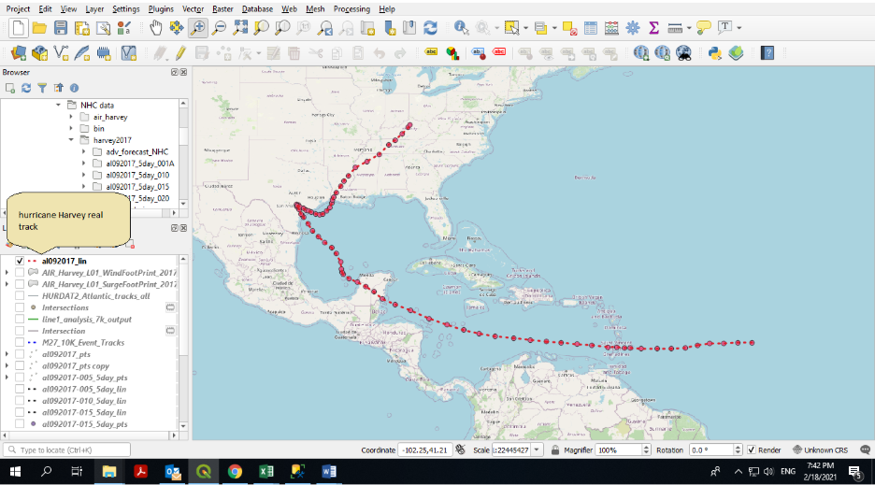
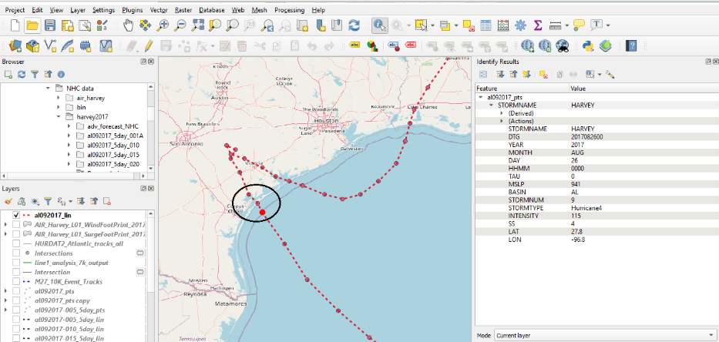
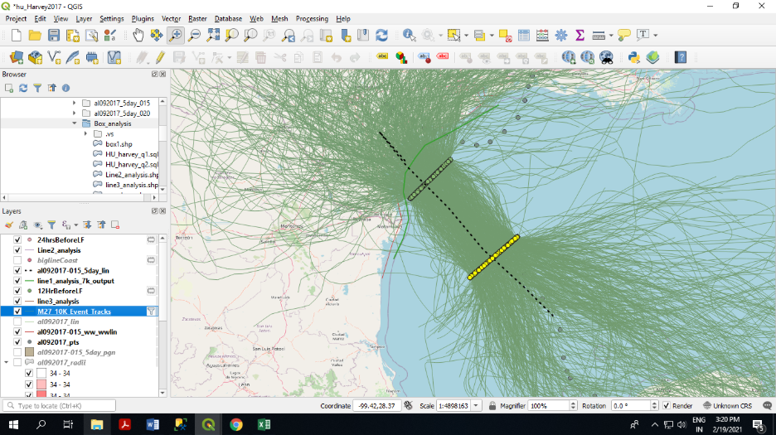
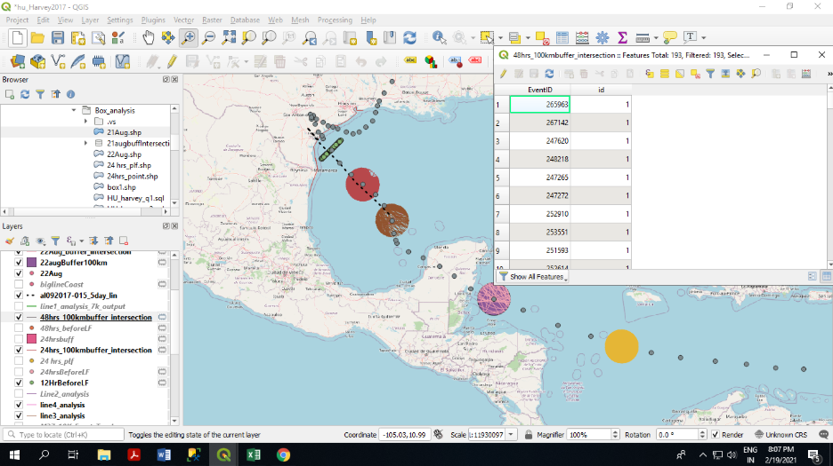
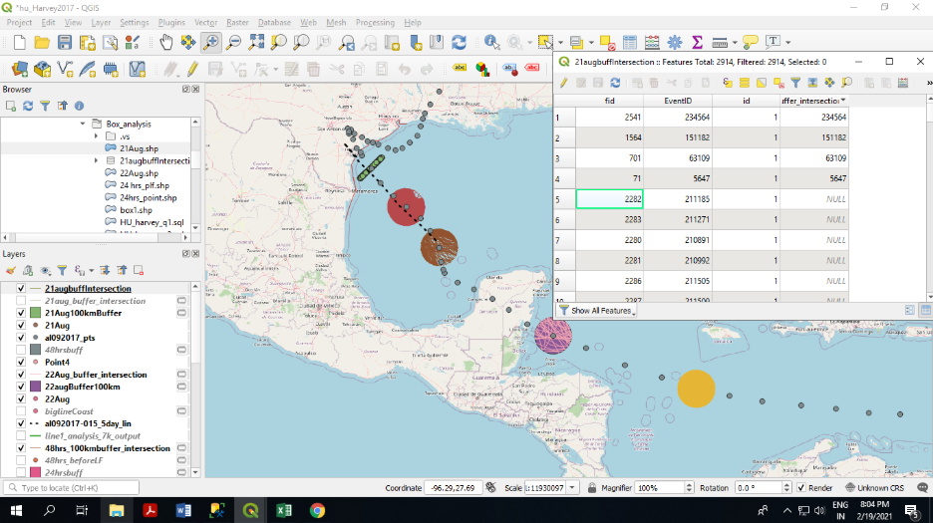
1. Identify Key Locations Along the Hurricane Track- Select important points along the hurricane's path, working backward from landfall.
Typical checkpoints/ buffers include- 12 hours, 24 hours, 48 hours before landfall
These checkpoints will represent the hurricane's position at different stages of development.
2. Initial Filtering Using Perpendicular Lines-
For each selected checkpoint:
- Draw a line approximately 200 km long.
- Position the line perpendicular to the hurricane track.
- Repeat for multiple checkpoints (e.g., 12 hours and 24 hours before landfall).
Historical or simulated events are then selected if their tracks intersect all selected lines.
Example
For Hurricane Harvey:
- A perpendicular line was created at the 12-hour pre-landfall point.
- Another perpendicular line was created at the 24-hour pre-landfall point.
- Events intersecting both lines were selected.
Result- Total AIR events analyzed: 2,914 and Events matching both lines: ~600
3-Refine Results Using Buffer Zones
The line-based approach may include events that intersect the lines but do not truly follow a similar path.
To improve accuracy- Replace perpendicular lines with circular buffer zones and create buffer around each checkpoint.
Use a buffer diameter of approximately 200 km and Select only events whose tracks pass through the buffer.
This approach better captures storms that traveled through the same geographic area.
4 Apply a 48-Hour Pre-Landfall Buffer
A 200 km buffer was created around the location of Hurricane Harvey 48 hours before final landfall. Events whose tracks passed through this buffer were selected.
Result- Events after line filtering: ~600 and Events after 48-hour buffer filtering: 191
5 Apply Geographic Path Constraints
Hurricane Harvey followed a specific route:
Atlantic Ocean < First landfall in Mexico < Crossed the Yucatán/Merida region < Entered the Gulf of Mexico < Final landfall in Texas
To further improve matching quality, only events following a similar route were retained.
Result- Events passing through the Mexico/Yucatán region: 56 and Events matching both the Mexico crossing and 48-hour buffer criteria: 25

6 Add Additional Checkpoints
An additional checkpoint was created approximately 24 hours earlier in the storm's development.
A second 200 km buffer was generated around this location.
Events were required to pass through: Buffer A (earlier checkpoint), Buffer B (48-hour checkpoint), Geographic route constraints
Result- Total AIR events: 2,914 and Final matching events: 4
7 Output- Small set of AIR Event IDs that closely match the historical track of Hurricane Harvey.
Summary of Event Reduction
Filtering Step | Remaining Events
Total AIR Events | 2,914
Intersect 12h & 24h Perpendicular Lines | ~600
Pass 48h Buffer Zone | 191
Pass Mexico/Yucatán Route Filter | 25
Pass All Buffer Zones and Route Criteria | 4

Parameter Based Approach-
Example 2- Earthquake Namie Japan Feb 2021
The event took place on the ocean of Japan and felt at the coasts. The Magnitude of the event was 7.1. Following parameters are chosen and queried to find like events from AIR catalogue.
Data was collected from AIR ALERT website. The basic information was updated on website as soon as event took place. The information that can be collected are like location of the event, magnitude, distance from the coast and initial updates.
Magnitude as 7.1, latitude as 37.745, longitude as 141.749, depth of the earthquake as 8.0, area as Japan, Tsunami event as ‘N’ and Maximum distance as 100. The query returned 40 like events. Further, the change in parameter input can further reduce the number of like events.
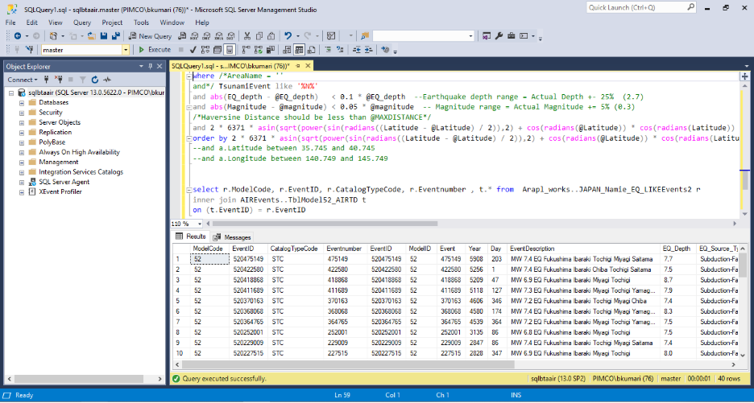
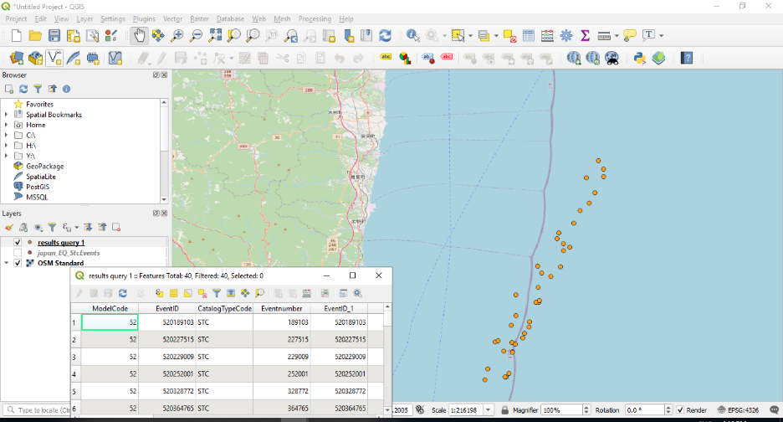
File path of event parameters based approach- "Y:\Live CAT Events\EVENT RESPONSE\A_EQ\jp_eq_namie_2.sql"

Epicentre based approach
The epicentre based approach is basically for the events occurring suddenly and causing the loss to specific region. For example, a lot of study has been conducted to monitor the seismic movement in depth, though, the earthquakes are difficult to predict and cause lot of damage. Wildfires are also similar because they occur suddenly and cause loss to forest and natural resources. Finding like event to estimate loss for these particular events can done with various approaches.
The latest event Namie Japan EQ on Feb 2021 with magnitude of 7.1 has been taken as an example to understand the process.
First the lat long of the event was stored in csv file with id as one attribute of the file. Save the file.
Open the csv file and save the layer the layer as point shapefile.
In order to find like events following parameters were taken- Magnitude as 7.1, latitude as 37.745, longitude as 141.749, depth of the earthquake as 8.0, area as Japan, Tsunami event as ‘N’ and Maximum distance as 100. The query returned 40 like events. Further, the change in parameter input can further reduce the number of like events.
Further querying can be done on following parameters-
- Earthquake source type- background-seismicity, subduction fault, crustal fault
- Magnitude- 5.000 to 9.086
- Earthquake depth- 3.2 km to 187.8 km
- Fault names- there are as many as 258 faults in and around Japan
- Epicentre type
- Area Name
- Sub area name- there are as many as 47 sub areas
- Triggering tsunami event- yes /no
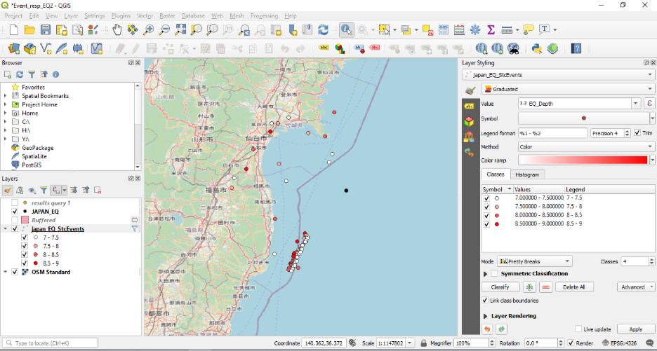
Step 1: In epicentre based approach, we took earthquake depth, magnitude and lat-long as prime parameters. The events are mapped taking event id and viewed in QGIS.
Step 2: Create buffer from geo-processing tool of 1 degree or 2 degree (area of interest) around the actual event point.
Step 3: Pass the event parameters mentioned above. Find the event id having presence in the buffer by the intersection along with the filtered parameters.
Step 4: Save the returned points in excel.
Additional data required-
Fault lines near Japan
https://www.j-shis.bosai.go.jp/en/downloads
https://gbank.gsj.jp/activefault/cgi/segment_param_e?SearchTYPE=&fval_type1=018-01&segment_id=018-01&topic_list=2&search_mode=2
US – faults data
The weighted distance method can be used for faults and epicentre based approach as one the factors.
Eq links to check-
https://earthquake.usgs.gov/earthquakes/map/?currentFeatureId=us6000dher&extent=34.76869,135.16479&extent=40.67231,148.32642&range=search&baseLayer=terrain&timeZone=utc&search=%7B%22name%22:%22Search%20Results%22,%22params%22:%7B%22endtime%22:%222021-03-06T14:07:50.397Z%22,%22latitude%22:37.7453,%22longitude%22:141.7494,%22maxradiuskm%22:250,%22minmagnitude%22:4,%22starttime%22:%222021-01-23T14:07:50.397Z%22%7D%7D
https://alert.air-worldwide.com/Downloads.aspx?e=881&tp=62&c=1
japan- https://www.jma.go.jp/bosai/map.html#10/41.509/141.504/&elem=int&contents=earthquake_map&lang=en s
Floods
Imp links for WMS layer from FEMA
https://hazards.fema.gov/femaportal/wps/portal/NFHLWMS
https://msc.fema.gov/portal/advanceSearch
https://www.fema.gov/flood-maps/national-flood-hazard-layer
Australia – river and floods data – they ask for email id
http://qldspatial.information.qld.gov.au/catalogue/custom/search.page?q=%22Flood%20extent%20polyline%20-%20February%202019%20-%20Flinders%20River%22
Colorado took Imelda event as flood event –
https://floodobservatory.colorado.edu/Events/4797/2019USA4797.html
Taxas providing lot of data pertaining to river water bodies precipitation etc
https://www.twdb.texas.gov/mapping/gisdata.asp

Basically, we are trying to find a single unit of data across all parameters for single event. The AIR shp contains Flood Depth, other shapefiles of the data like flood footprint needs to be gradually categorized. AIR db data should have mean precipitation, Catchment capacity and DEM or elevation data for better depth analysis.
Flood factors in US- hurricane induced floods- cause storm surge and storm tides
Sno | AIR DB | Actual events parameters | Parameter required | Parameter required
source | AIRs’ DB- US model 08 |  | AIR DB- Britain inland | Touchstone
1 | Lat long – box shape | Flood depth- individual Polygons contains only flood depth data  Flood depth- Useful APIs can be called from here http://nationalflooddata.com/flood/ like base flood elevation, flood zones etc. | Rainfall- mean, min, max  mean runoff, | Distance to water body  (FEMA)
2 | time to first run off , time to last run off | DEM | mean normal discharge, duration, | Base flood elevation (FEMA)
3 | time to first peak flow,  time to last peak flow |  | Drainage data- length of the water body, Nearest waterbody,  Distance to the water body | Flood zone (FEMA)  Flood zone category (FEMA)
4 | no of catchments flooded,  area of the catchment flooded, |  | Areas affected (states /counties /admin boundaries) | Flood zone category (AIR)
5 | length of the links floods |  |  | Elevation (AIR)

The approach to the flood is different from other approaches – the notional exposure approach.
The coloured parameters discussed above are important ones. The data collected for real event through event news or first report from any source like NHC, ALERT etc can give some parameters. These parameters can be initial area of interest where hurricane is approaching (state, county, admin boundaries etc), rainfall, windfall, wind-speed etc. The digits in the report or summary can be captured in excel manually.
When area of interest is known with respect to some administrative boundary we can assign some lat long pertaining to that particular state or county or area; we can the related other data like flood zone, distance to nearest water body/ river, flood zone category, elevation, base flood elevation, can be accessed from FEMA.
The related data to the water body or nearest river can be known like catchment, its mean capacity, maximum capacity etc. these parameters are there in AIR Db for stochastic events. We can find like events based on area, catchment, capacity by querying the parameters. (finding similar events in initial part of event)
Post event- the shape files are available. With the help of available detailed exposure and damage ratio the loss estimation would be more accurate.

